|  |  |  |  |
| --- | --- | --- | --- |
| 1 | | 66,854 | |
| **NUMERO DE FRONTERAS** | | **ENERGIA AGREGADA** | |
|  | | | |
| 231,576,339 | 150 | | 8,853,001 |
| INGRESO 2019 | DÍAS CERTIFICADOS 2019 | | ENERGIA RESPALDADA 2019 |
|  | | | |
| 292,789,602 | 203 | | 10,997,188 |
| INGRESO 2020 | DÍAS CERTIFICADOS 2020 | | ENERGIA RESPALDADA 2020 |
|  | | | |
| 170,248,902 | 109 | | 7,499,824 |
| INGRESO 2021 | DÍAS CERTIFICADOS 2021 | | ENERGIA RESPALDADA 2021 |

**HISTORICO REINTEGRO DDV**

|  |  |  |  |
| --- | --- | --- | --- |
|  | **2019** | **2020** | **2021** |
| **ENE** | - | 39.73 | 29.96 |
| **FEB** | 22.21 | 50.58 | 41.24 |
| **MAR** | 1.18 | 62.13 | - |
| **ABR** | 26.23 | - | - |
| **MAY** | 29.2 | 11.81 | - |
| **JUN** | 24.02 | 14.69 | - |
| **JUL** | - | 12.26 | 18.16 |
| **AGO** | - | 16.15 | 32.35 |
| **SEP** | 17.81 | 12.3 | 28.04 |
| **OCT** | 35.33 | 7.53 | 20.5 |
| **NOV** | 56.23 | 31.54 | - |
| **DIC** | 19.36 | 34.07 | - |

**Los valores de la tabla están en millones de COP**

**REINTEGRO MECANISMO DDV OCTUBRE 2021**

|  |  |  |  |  |  |
| --- | --- | --- | --- | --- | --- |
| FECHA | TIPO DIA | CANTIDADES RESPALDO | PRECIO PONDERADO USD | TRM | PNETO |
| 2021-10-06 | Miércoles | 67,221 | 5.98 | 3,784.44 | 1,363,063 |
| 2021-10-07 | Jueves | 67,243 | 5.98 | 3,784.44 | 1,363,509 |
| 2021-10-08 | Viernes | 68,203 | 5.98 | 3,784.44 | 1,382,975 |
| 2021-10-09 | Sábado | 67,989 | 5.98 | 3,784.44 | 1,378,636 |
| 2021-10-10 | Domingo - Festivo | 66,537 | 5.98 | 3,784.44 | 1,349,193 |
| 2021-10-11 | Lunes | 67,149 | 5.98 | 3,784.44 | 1,361,603 |
| 2021-10-18 | Domingo - Festivo | 67,221 | 5.98 | 3,784.44 | 1,363,063 |
| 2021-10-19 | Martes | 67,245 | 5.98 | 3,784.44 | 1,363,549 |
| 2021-10-20 | Miércoles | 68,203 | 5.98 | 3,784.44 | 1,382,975 |
| 2021-10-21 | Jueves | 67,219 | 5.98 | 3,784.44 | 1,363,022 |
| 2021-10-22 | Viernes | 67,243 | 5.98 | 3,784.44 | 1,363,509 |
| 2021-10-23 | Sábado | 67,075 | 5.98 | 3,784.44 | 1,360,102 |
| 2021-10-24 | Domingo - Festivo | 67,989 | 5.98 | 3,784.44 | 1,378,636 |
| 2021-10-25 | Lunes | 66,547 | 5.98 | 3,784.44 | 1,349,396 |
| 2021-10-26 | Martes | 67,989 | 5.98 | 3,784.44 | 1,378,636 |

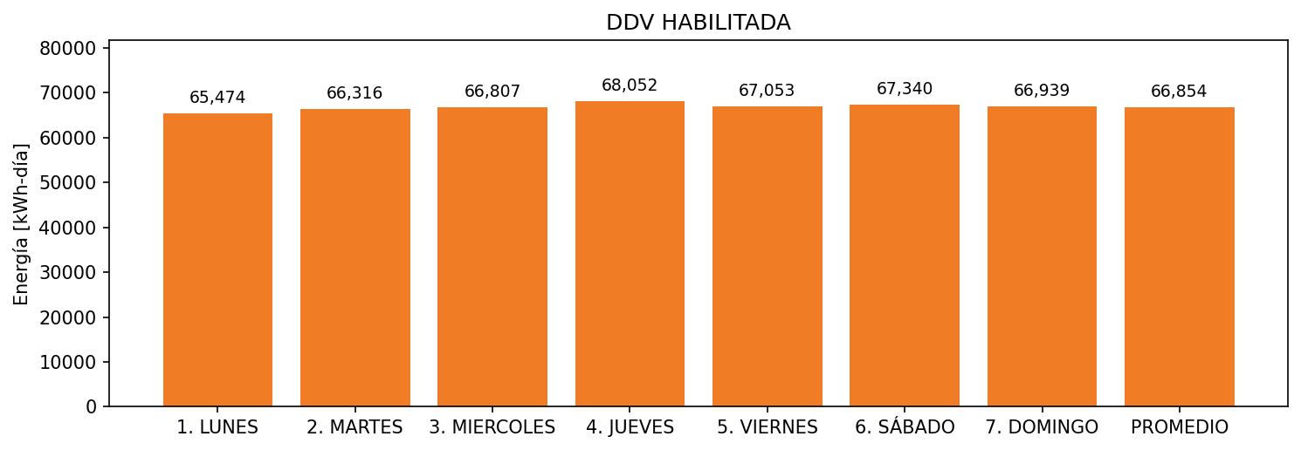

|  |  |  |  |  |  |  |  |  |  |
| --- | --- | --- | --- | --- | --- | --- | --- | --- | --- |
| **FRONTERA** | **COD SIC** | **FRT DDV** | **TIPO DDV** | **PROMEDIO** | **PRÓXIMA ACTUALIZACIÓN** | **MARGEN DE ERROR** | **ÚLTIMA PRUEBA DDV** | **DÍAS PARTICIPACIÓN** | **FECHA REFERENCIA PRÓXIMA PRUEBA DDV** |
| CERAMICA ITALIA | Frt10371 | Frt31451 | LBC | 66,854 | 2022-02-25 | 1,82 | 2021-07-01 | 65.0 | 2021-12-26 |